Purpose:
- To reflect SQF Requirements

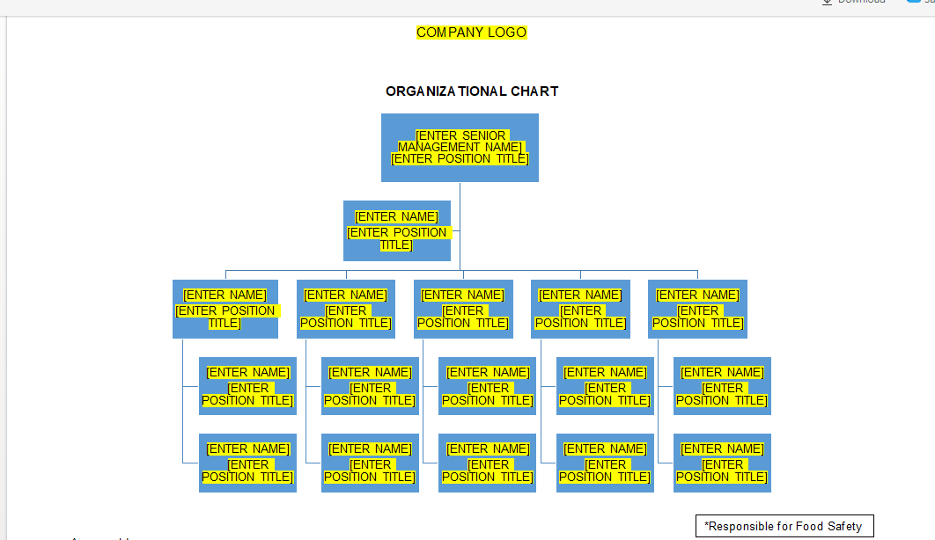

- Generation of Organizational Chart

- To add a tab that can generate Organizational Chart

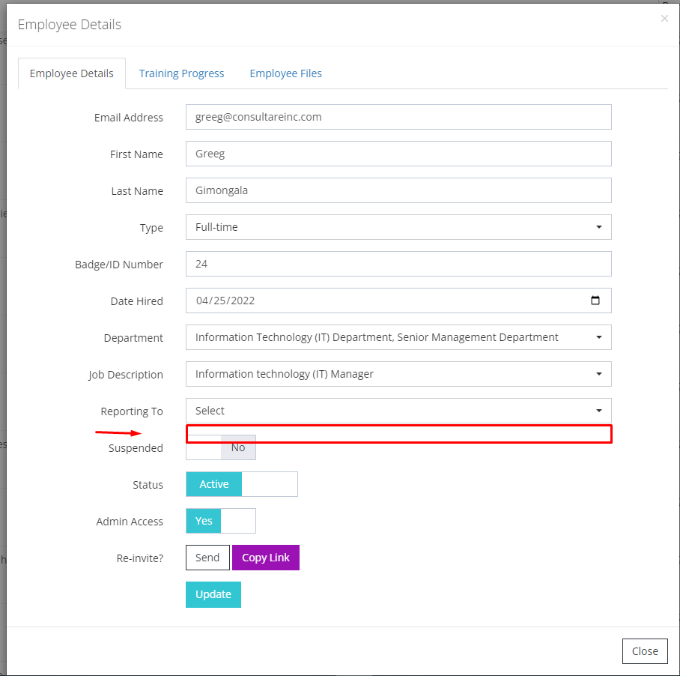
- To add a field that can identify if the employee is responsible for Food Safety this is under Employee Roster - Employee Details.

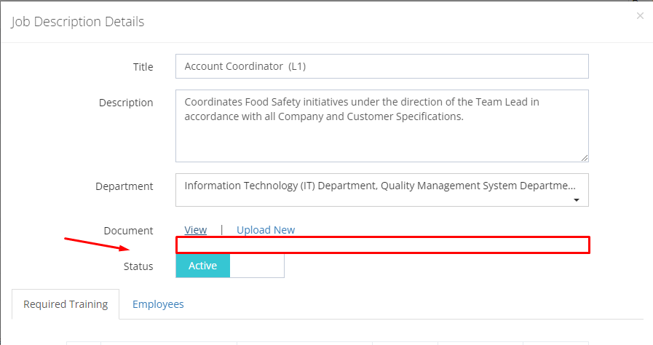
- To add the “Reporting to” field this is need to connect the positions this is under Job description details.

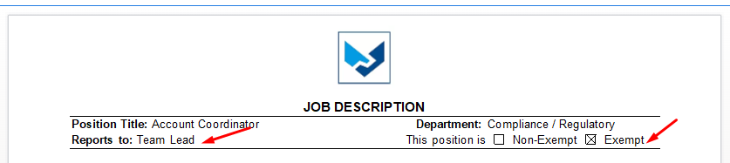
- To add Non-Exempt/Exempt, as per miss Ez.

